
LAB 11

Submitted by:

Submitted by:

Name | Registration No.
Muhammad Abdullah | FA24-BSE-042

Submitted to: Sir Waqas
Course: Artificial intelligence (AI)
Dated: Nov 29, 2025.

DEPARTMENT OF COMPUTER SCIENCE
COMSATS UNIVERSITY ISLAMABAD,
Lab 11

Activity:
Code:

from csp import CSP, Constraint

class MapColoringConstraint(Constraint[str, str]):
def __init__(self, place1: str, place2: str):
super().__init__([place1, place2])
self.place1 = place1
self.place2 = place2

def satisfied(self, assignment: dict[str, str]) -> bool:
# If either place not yet assigned, no conflict
if self.place1 not in assignment or self.place2 not in assignment:
return True
# Conflict if both have the same color
return assignment[self.place1] != assignment[self.place2]

if __name__ == "__main__":
# Variables: Regions of Australia
variables = ["WA", "NT", "SA", "Q", "NSW", "V", "T"]

# Domains: Possible colors
domains = {var: ["Red", "Green", "Blue"] for var in variables}

# Create CSP instance
csp = CSP(variables, domains)

# Add adjacency constraints
csp.add_constraint(MapColoringConstraint("WA", "NT"))
csp.add_constraint(MapColoringConstraint("WA", "SA"))
csp.add_constraint(MapColoringConstraint("NT", "SA"))
csp.add_constraint(MapColoringConstraint("NT", "Q"))
csp.add_constraint(MapColoringConstraint("SA", "Q"))
csp.add_constraint(MapColoringConstraint("SA", "NSW"))
csp.add_constraint(MapColoringConstraint("SA", "V"))
csp.add_constraint(MapColoringConstraint("Q", "NSW"))
csp.add_constraint(MapColoringConstraint("NSW", "V"))

# Solve CSP
solution = csp.backtracking_search()

# Print solution
if solution:
print("Solution found:")
for region, color in solution.items():
print(f"{region}: {color}")
else:
print("No solution found.")

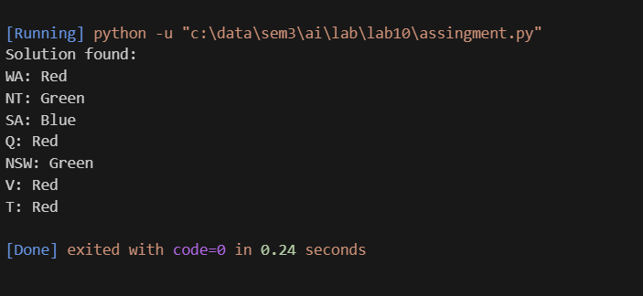
Task:
from typing import Dict, List
from csp import CSP, Constraint

class QueensConstraint(Constraint[int, int]):
def __init__(self, row1: int, row2: int) -> None:
super().__init__([row1, row2])
self.r1 = row1
self.r2 = row2

def satisfied(self, assignment: Dict[int, int]) -> bool:
# If either row isn't assigned a column yet, no conflict
if self.r1 not in assignment or self.r2 not in assignment:
return True
c1 = assignment[self.r1]
c2 = assignment[self.r2]
# Constraint 1: different columns
if c1 == c2:
return False
# Constraint 2: different diagonals (row difference equals column difference)
return abs(c1 - c2) != abs(self.r1 - self.r2)

def print_board(n: int, solution: Dict[int, int]) -> None:
board = []
for r in range(n):
row = ['.'] * n
if r in solution:
row[solution[r]] = 'Q'
board.append(' '.join(row))
print("\n".join(board))

if __name__ == "__main__":
n = 4
# Variables: rows 0..3
variables = list(range(n))
# Domains: columns 0..3 for each row
domains: Dict[int, List[int]] = {r: list(range(n)) for r in variables}

csp: CSP[int, int] = CSP(variables, domains)

# Add all pairwise constraints (binary constraints between rows)
for r1 in range(n):
for r2 in range(r1 + 1, n):
csp.add_constraint(QueensConstraint(r1, r2))

solution = csp.backtracking_search()

if solution:
print("Solution found (row -> column):")
for r in sorted(solution.keys()):
print(f"Row {r}: Col {solution[r]}")
print("\nBoard:")
print_board(n, solution)
else:
print("No solution found.")

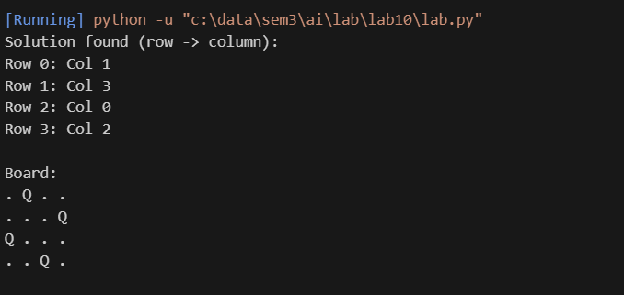

Pakistan map colouring:
from typing import Dict
from csp import CSP, Constraint

class MapColoringConstraint(Constraint[str, str]):
def __init__(self, region1: str, region2: str):
super().__init__([region1, region2])
self.region1 = region1
self.region2 = region2

def satisfied(self, assignment: Dict[str, str]) -> bool:
if self.region1 not in assignment or self.region2 not in assignment:
return True
return assignment[self.region1] != assignment[self.region2]

if __name__ == "__main__":
variables = ["Punjab", "Sindh", "Balochistan", "KPK", "Gilgit", "AJK", "Islamabad"]
domains = {region: ["Red", "Green", "Blue","yellow"] for region in variables}

csp = CSP(variables, domains)

adjacent_pairs = [
("Punjab", "Sindh"),
("Punjab", "Balochistan"),
("Punjab", "KPK"),
("Punjab", "Islamabad"),
("Punjab", "AJK"),
("Sindh", "Balochistan"),
("Balochistan", "KPK"),
("KPK", "Gilgit"),
("KPK", "AJK"),
("AJK", "Gilgit"),
("Islamabad", "KPK"),
("Islamabad", "AJK")
]

for region1, region2 in adjacent_pairs:
csp.add_constraint(MapColoringConstraint(region1, region2))

solution = csp.backtracking_search()

if solution:
print("Pakistan Map Coloring Solution:")
for region, color in solution.items():
print(f"{region}: {color}")
else:
print("No solution found.")

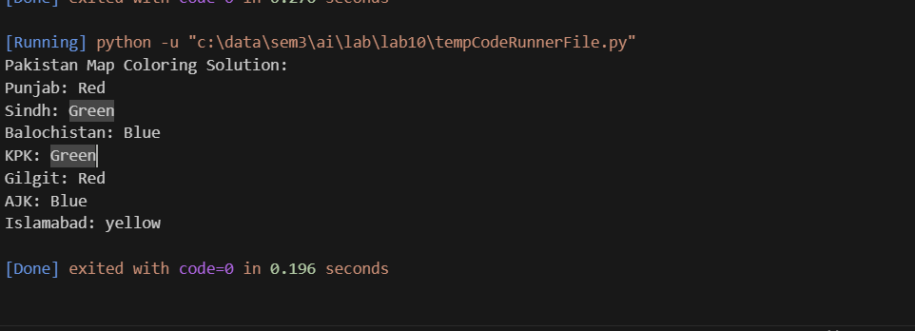
With 4 colors
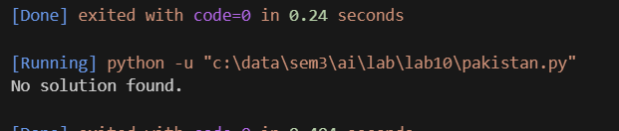
With 3 colours

